**Execute using following command from the same location where jar file is present:**

***Java -jar <name of the jar file>***

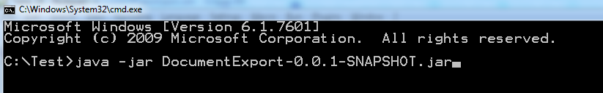

## Example Scenario:

**Employee** class with following custom metadata.

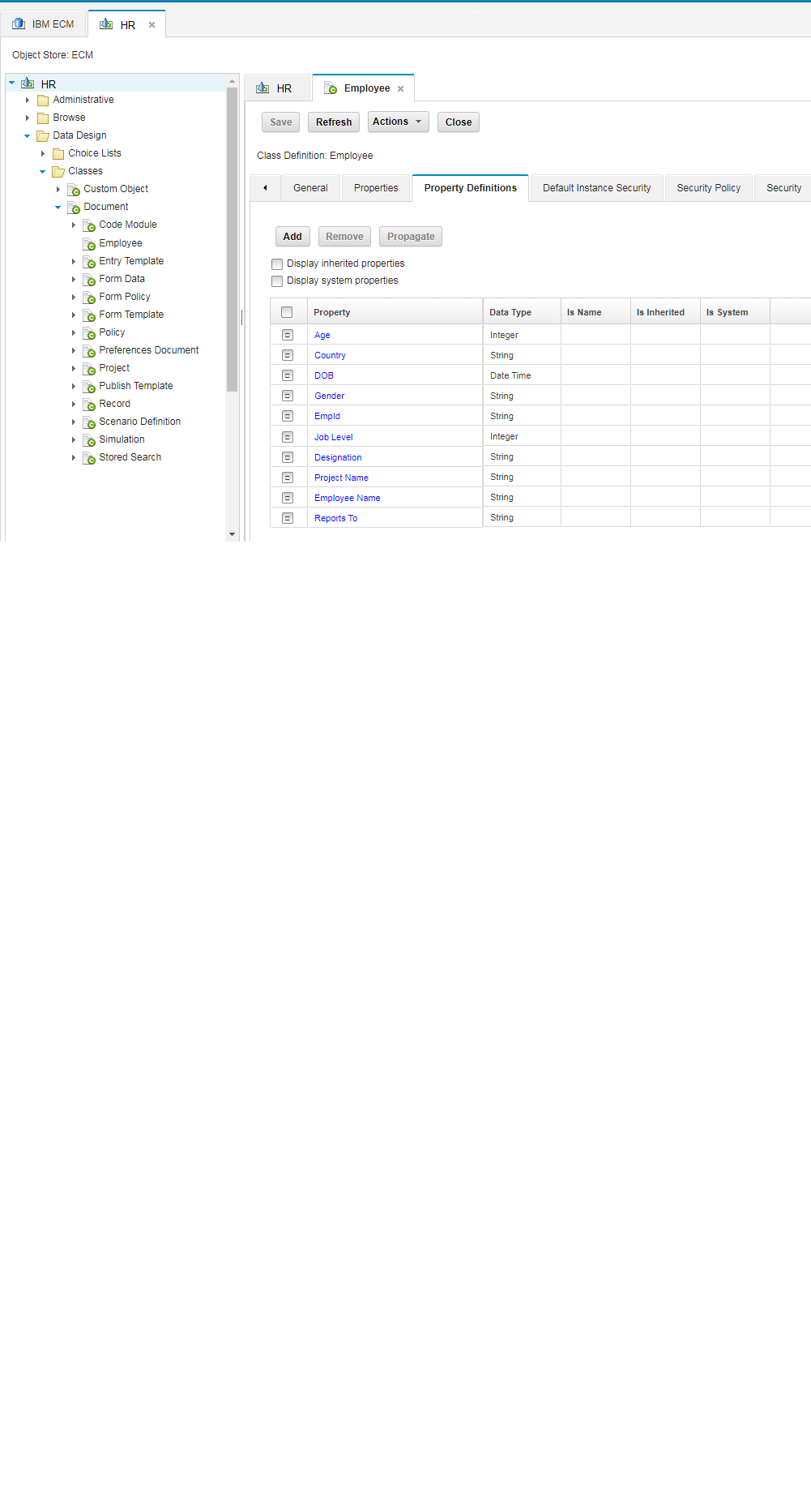

**Contents of the folder before execution of the application:**

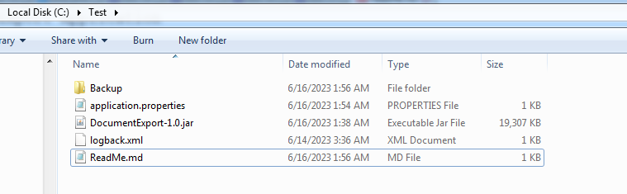

**Execution screen capture:**

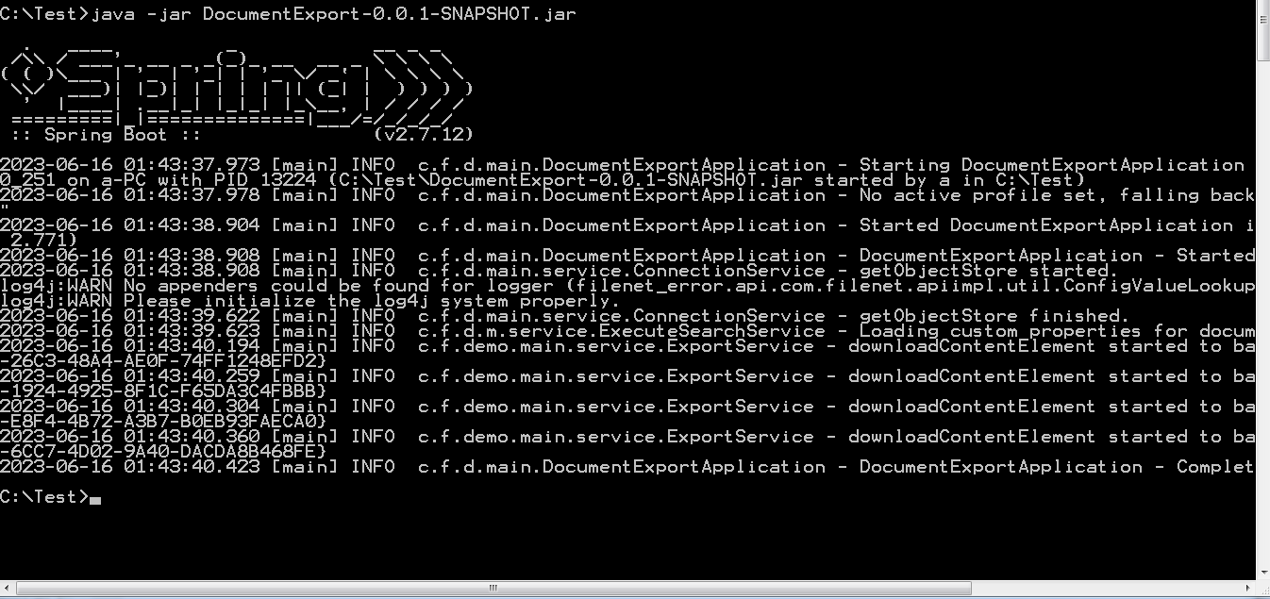

**Contents of the folder after execution of the application:**

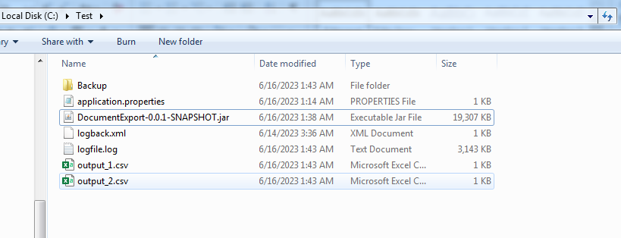

**Output and log file**



